**ONLINE BOOKING SYSTEM**

**APTECH** Computer Education

E-project of ACCP (Second Semester)

Gulistan-e-Johar, Karachi

ACKNOWLEDGEMENT

We are thankful to almighty, **ALLAH** with his grace and mercy for giving us strength and ability to make us complete this e-Project website. We hereby presenting project on **“ACCP APP”**in your hands.

We have tried our best to take all relevant and important topics in consideration so that this project may become more effective & a better outlook to come. This project has been developed with the help of “HTML, CSS, BOOTSTRAP / JAVASCRIPT, JQUERY, PHP CORE”.

We earnestly hope that this project will provide all the necessary information required for the user to fulfill their requirement. However, suggestions for improvement of the project will be thankfully acknowledge.

**THANK YOU**

PREFACE

First of all, we would like to thank **ALLAH** the almighty, who gave us mind to think and heart to feel creativity & creation depends on thinking.

Many people contributed to this project, and I would like to thank all of them. Very special thanks to our teacher **SIR Abdull Rehman** of **APTECH** for his expert advice and brilliant suggestion and always encourage us to do the best. Indeed class fellows are very important and we would like to thank all of them for their kind appreciation, encouragement and moral support.

We would also like to express our deepest gratitude to our parents whose well wishes enabled us to transform our dream into a reality.

Finally, our sincere thanks to our teacher **SIR Abdull Rehman** for all their assistance in making this concept a reality.

TABLE OF CONTENTS

Sessions

1. Introduction 04
2. Road Map 05
3. Home page 06
4. Coming soon 07
5. Footer 08
6. Now showing 09
7. Slider 10
8. Movies 11
9. Reserved Seat 12
10. Booking pages 13
11. Movies 14
12. Registration form 15
13. Login form 16
14. Admin panel login form 17
15. Book: 18
16. Movie list 19
17. Theater 20
18. Member of project 21

INTRODUCTION

Online Movie Ticket Booking

System in php

“**Introduction the online Movies Ticket Booking System”**

Online movie booking system is a web portal where you can book tickets in advance, know your movie show timing, watch movie trailer and read reviews for the same.

The objective of Cinema Reservation System is to provide the facility of booking movie tickets online. Customer can view timing of movie shows and book the show as per the availability. Cinema Reservation System is a PHP/MySQL based.

This project provides ticket reservation system allowing bookings in a few easy steps. Users can easily book for Shows, Change time, Delete order and view all the shows available.

FONT END

BACK END* Php core

Admin Panel

SITE MAP

|  |
| --- |
| * Snap shots |

Home Page:

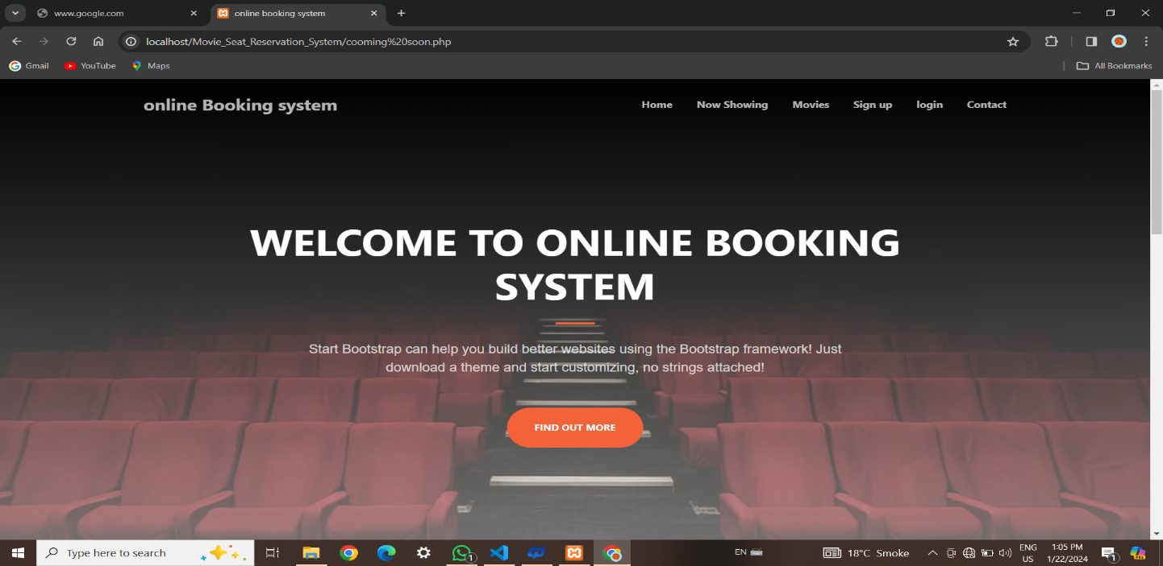

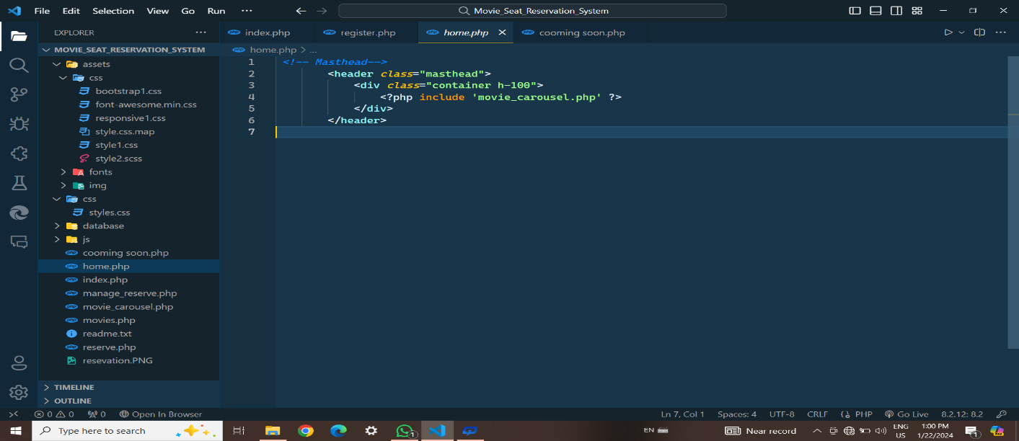

Coming Soon Movies

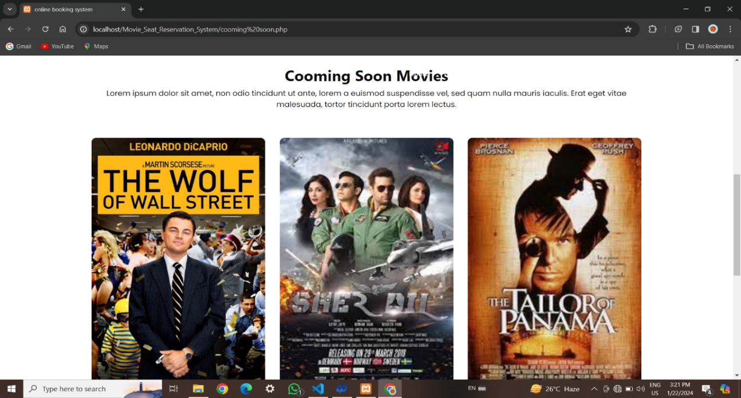

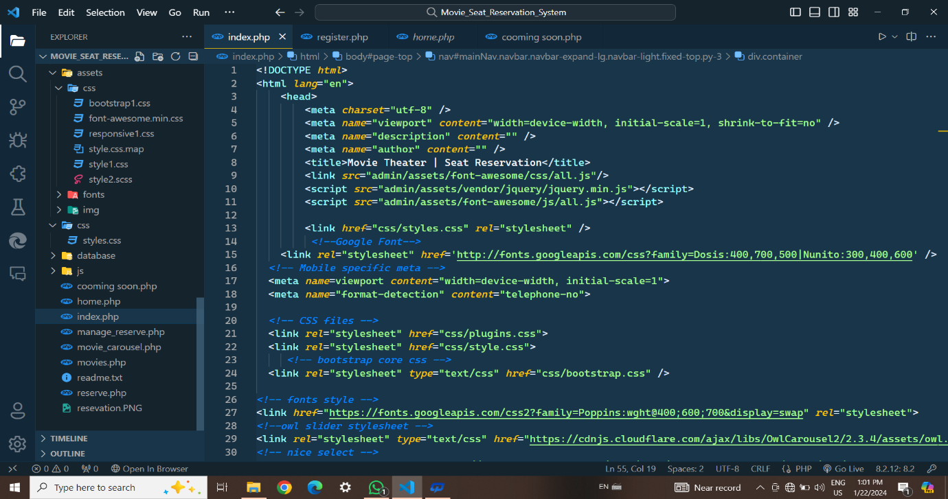

Footer:

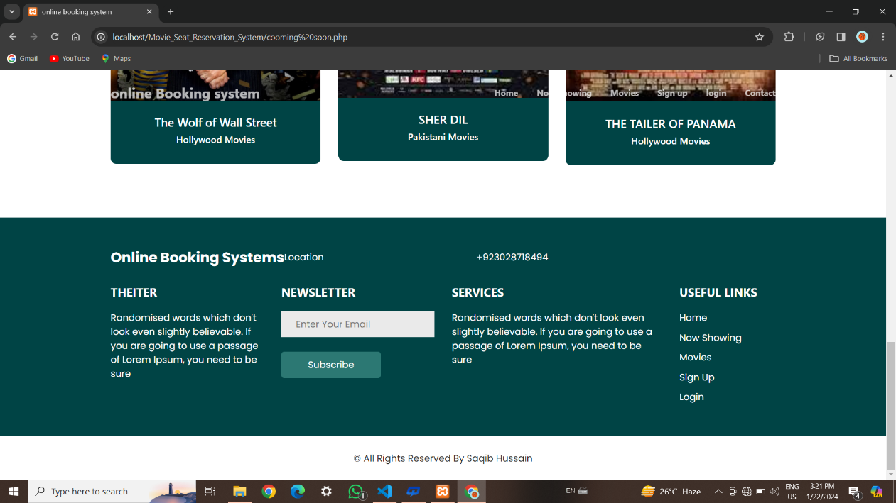

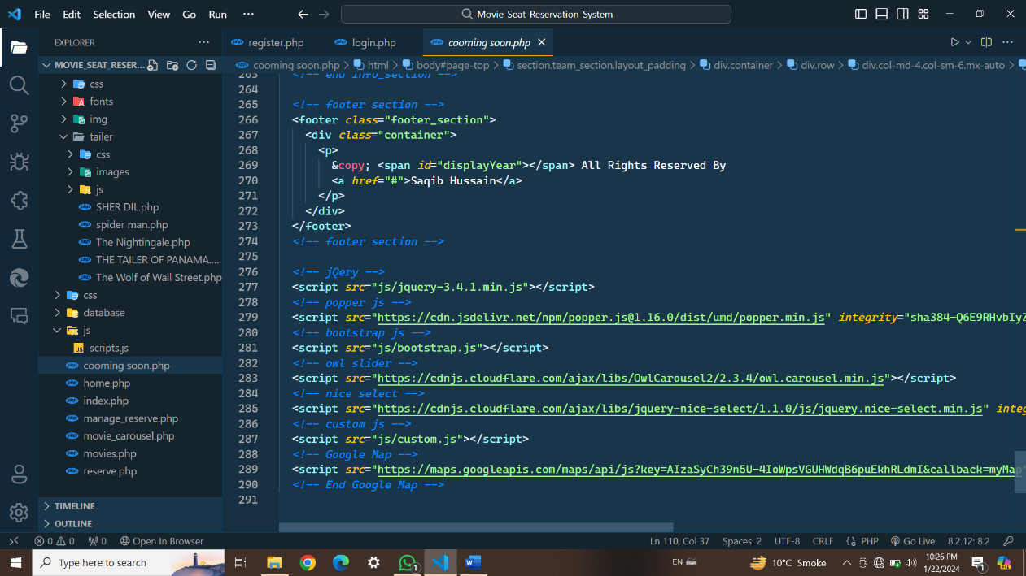

Showing Now:

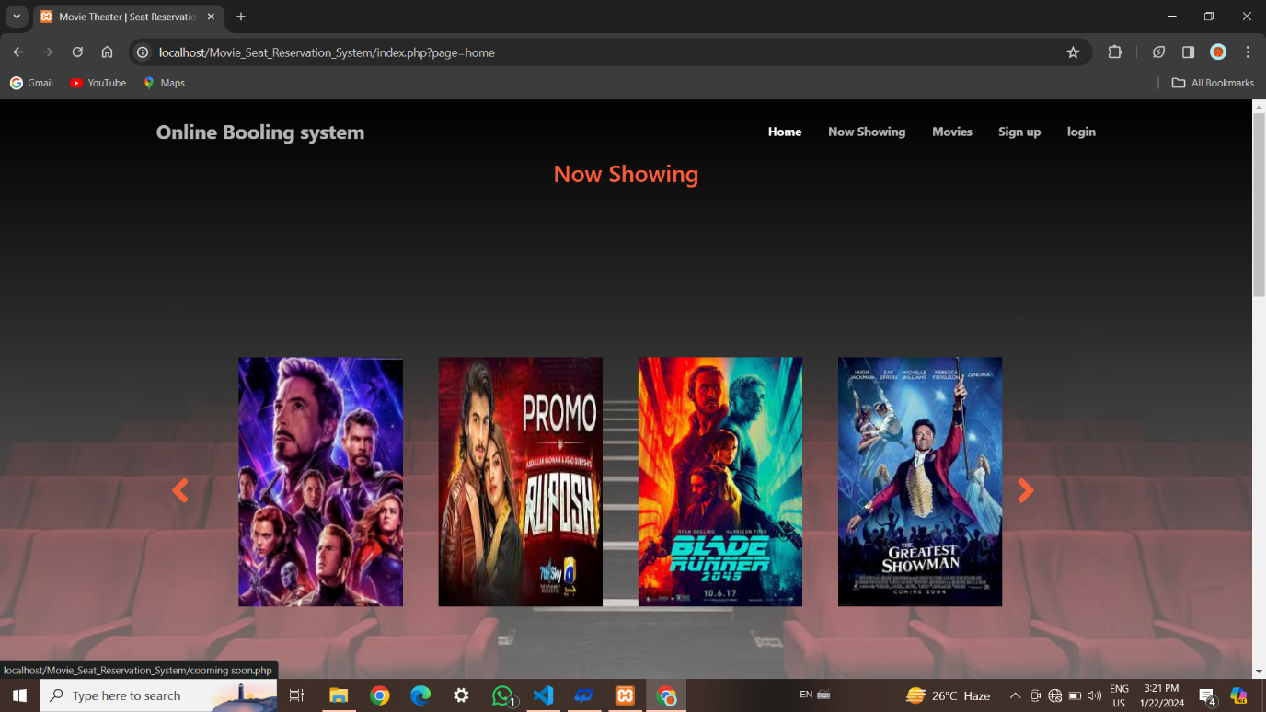

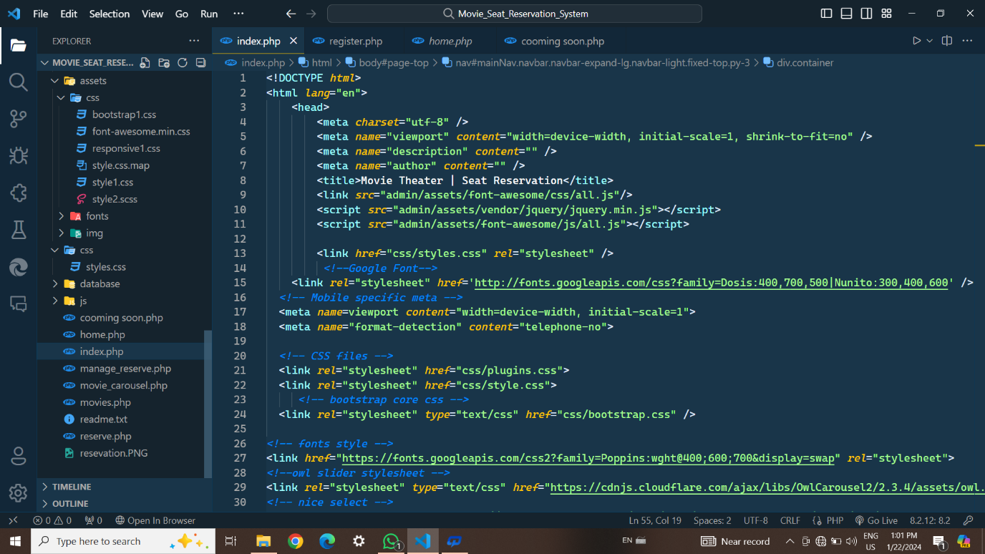

Slider  
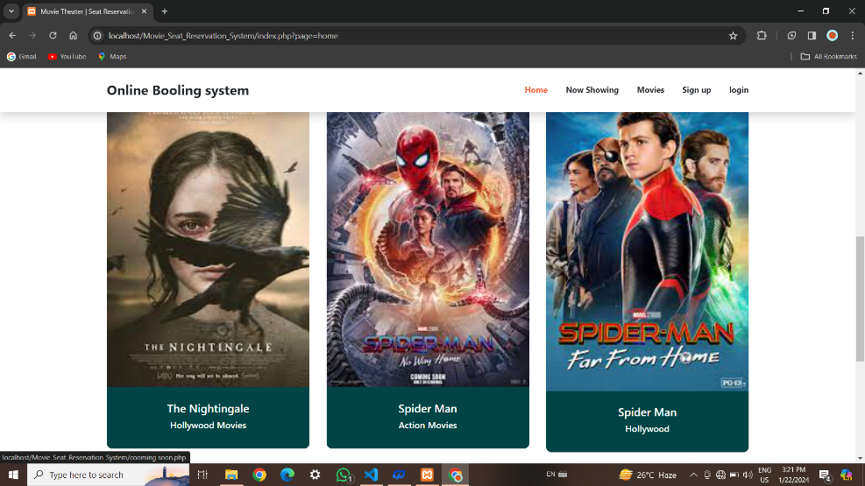

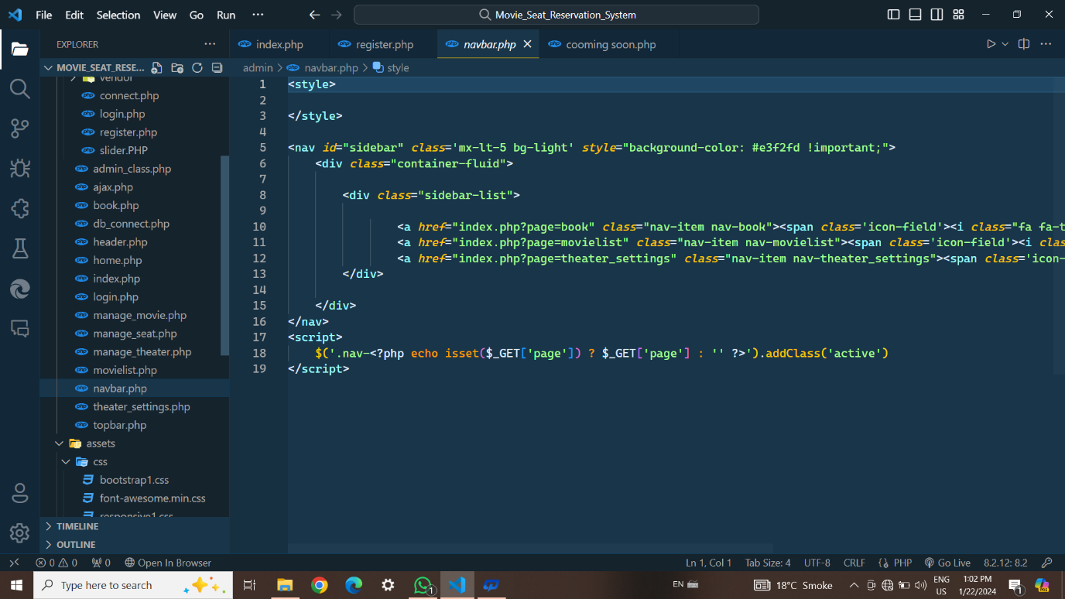

Movies

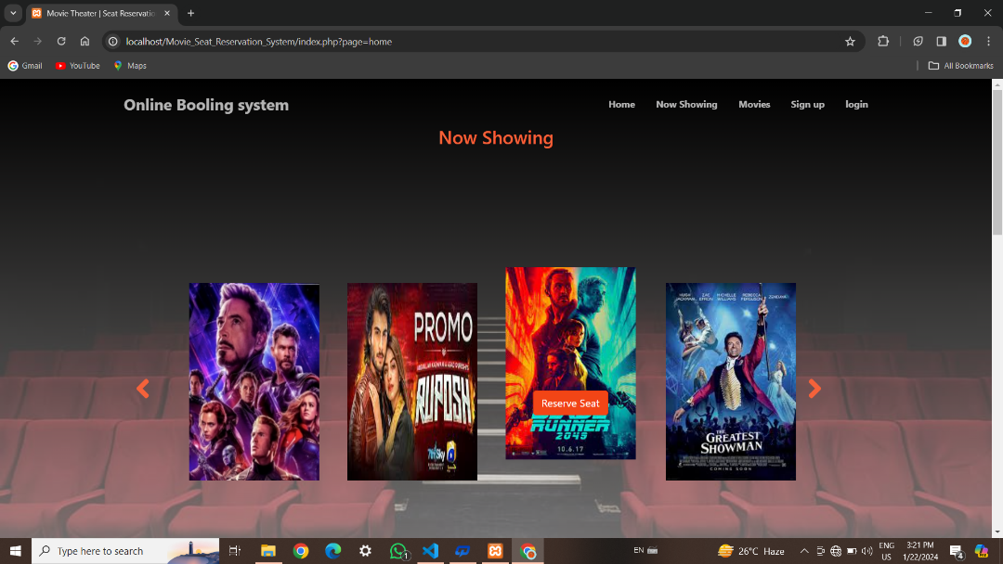

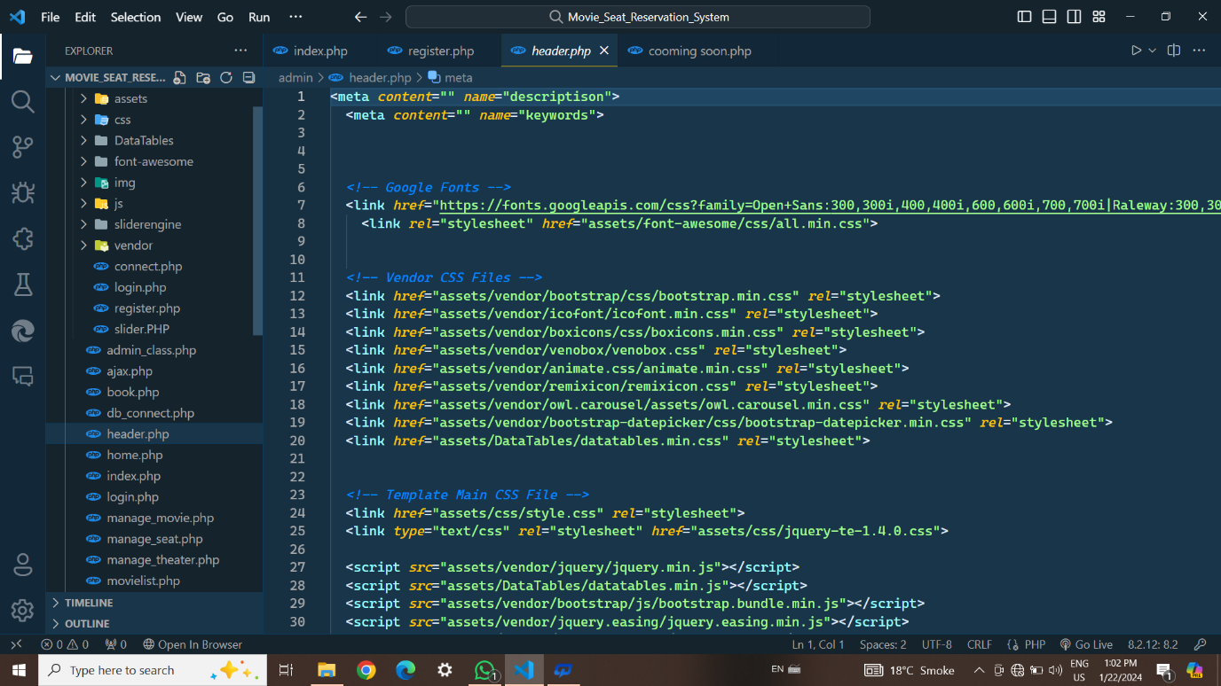

Reserve Seat:

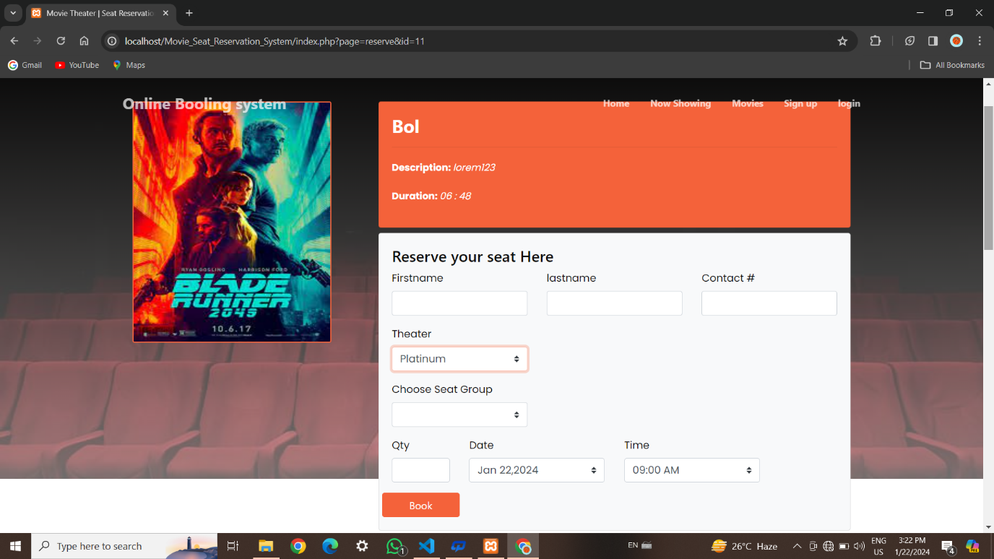

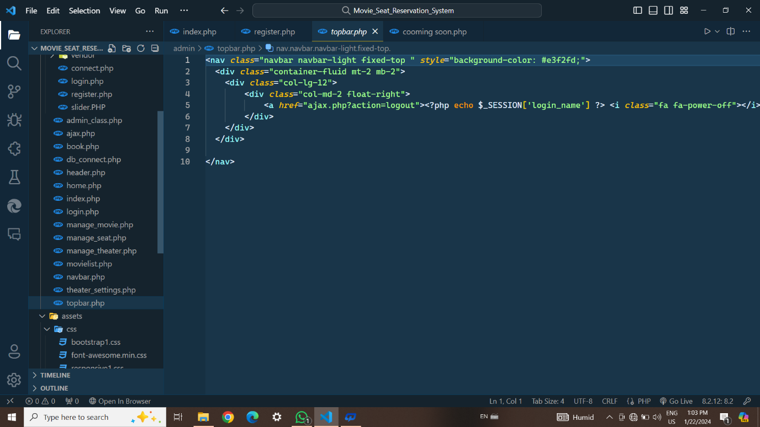

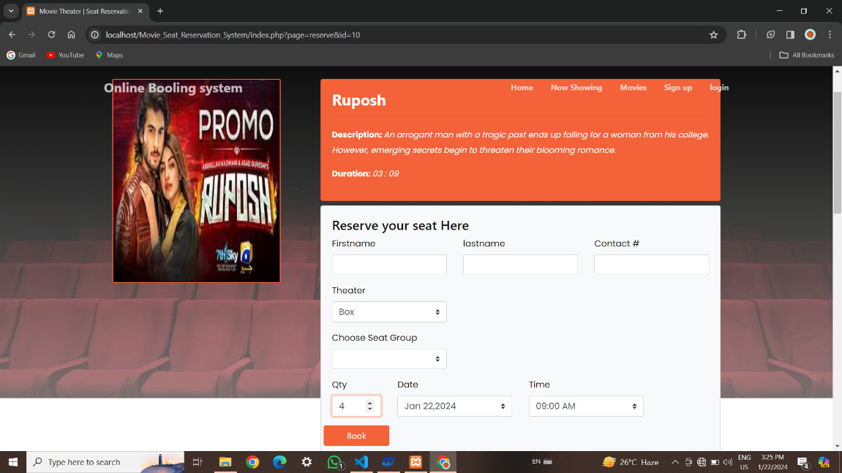

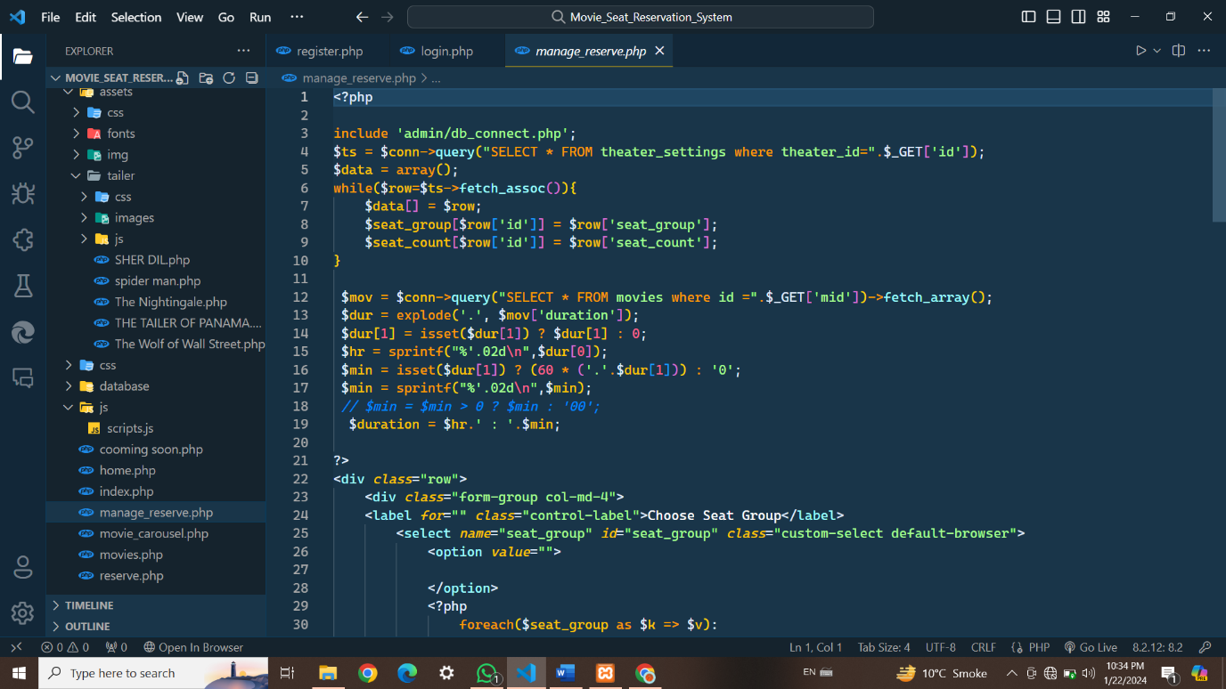

Movies

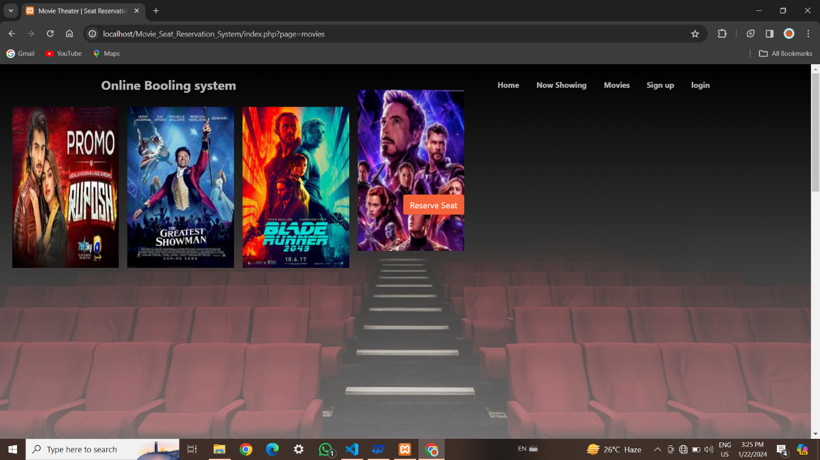

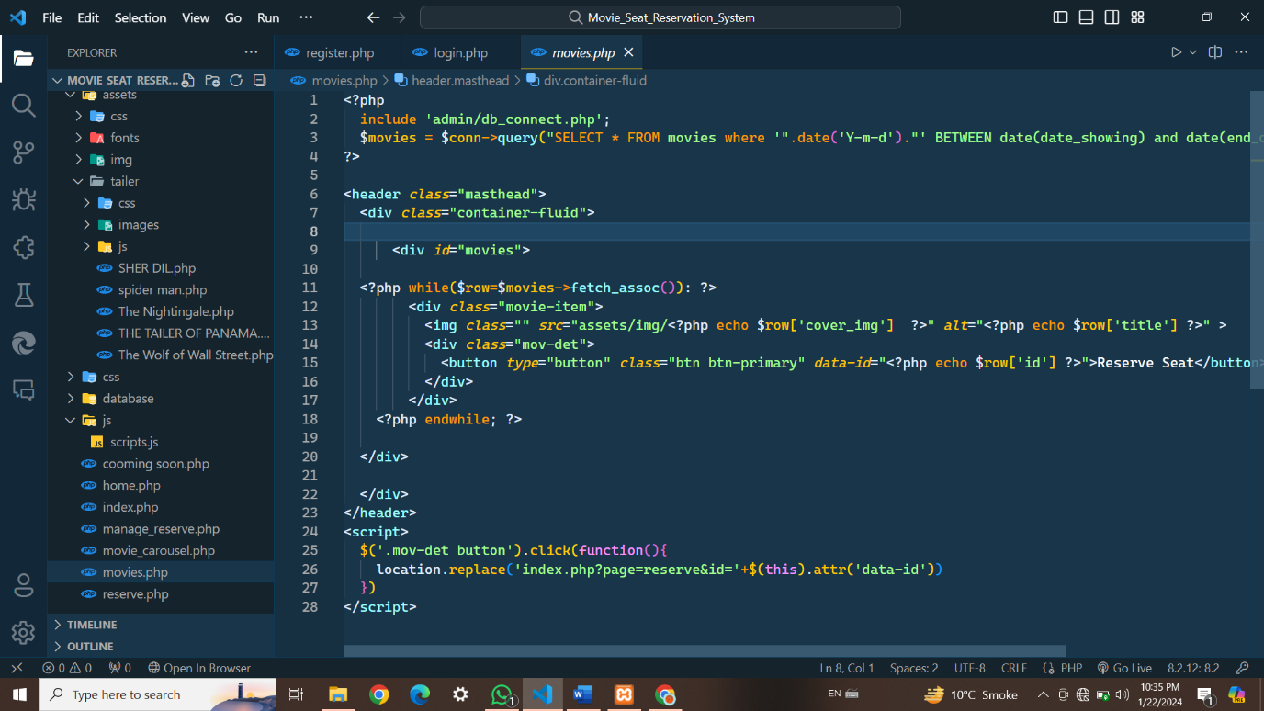

Register Form:

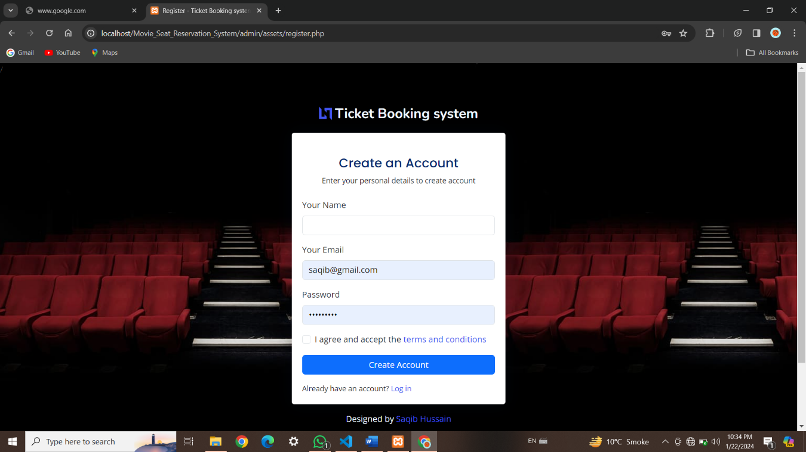

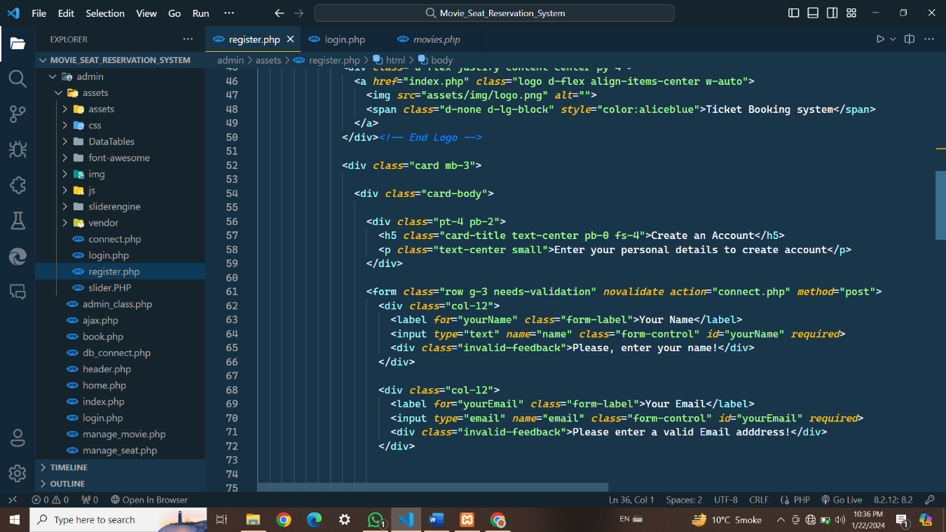

Login Form:

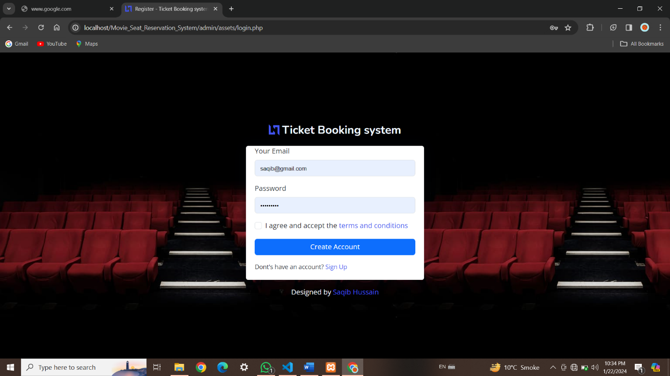

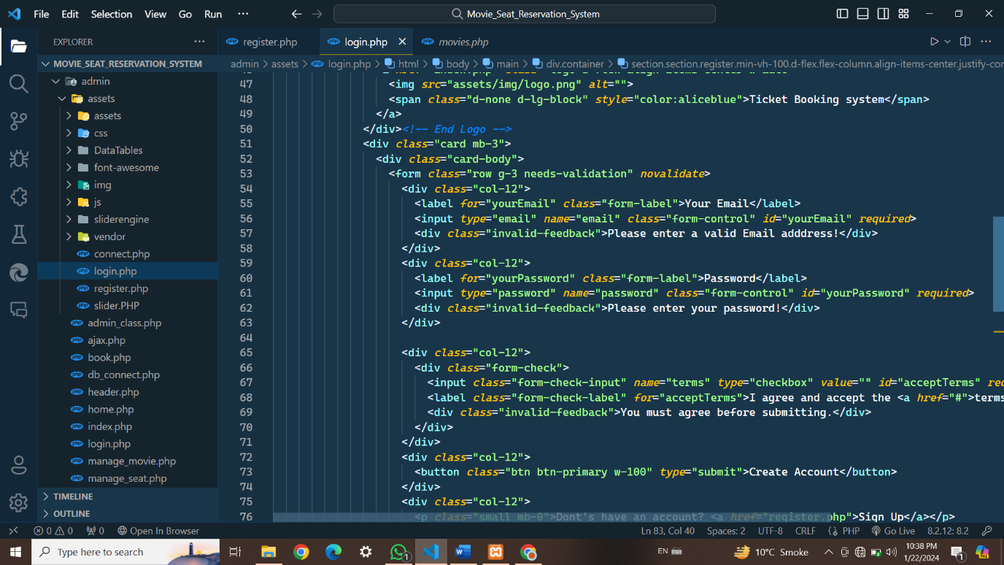

Admin panel : login form

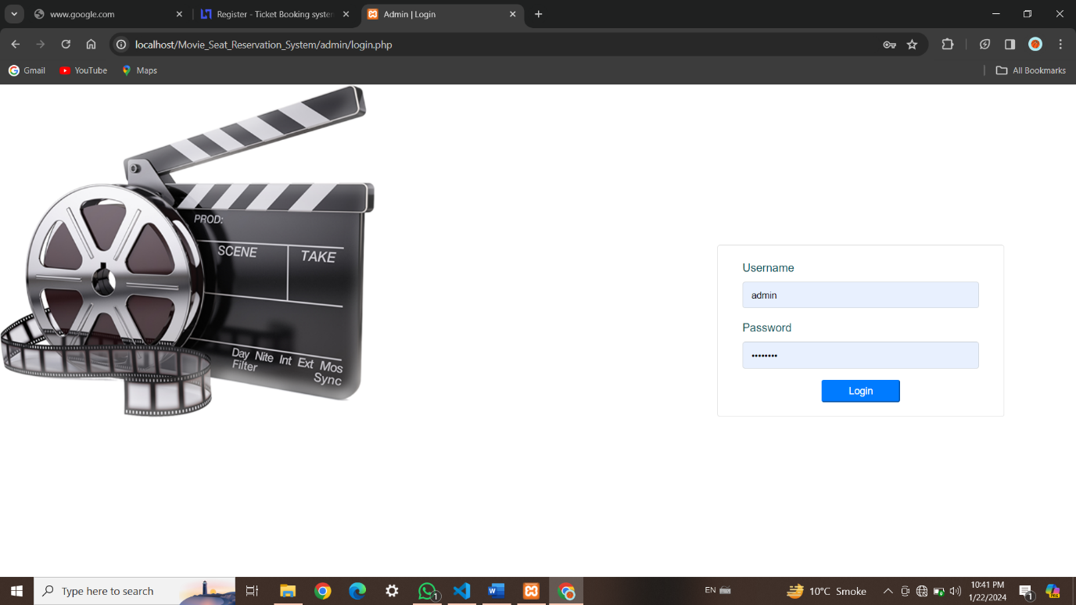

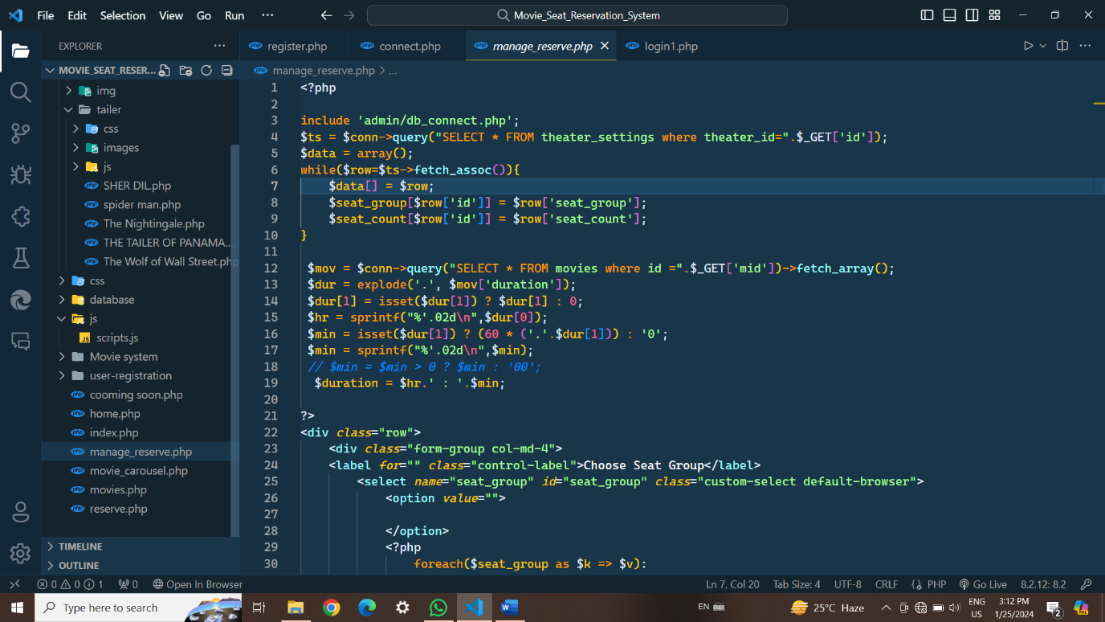

Admin panel ( books) :

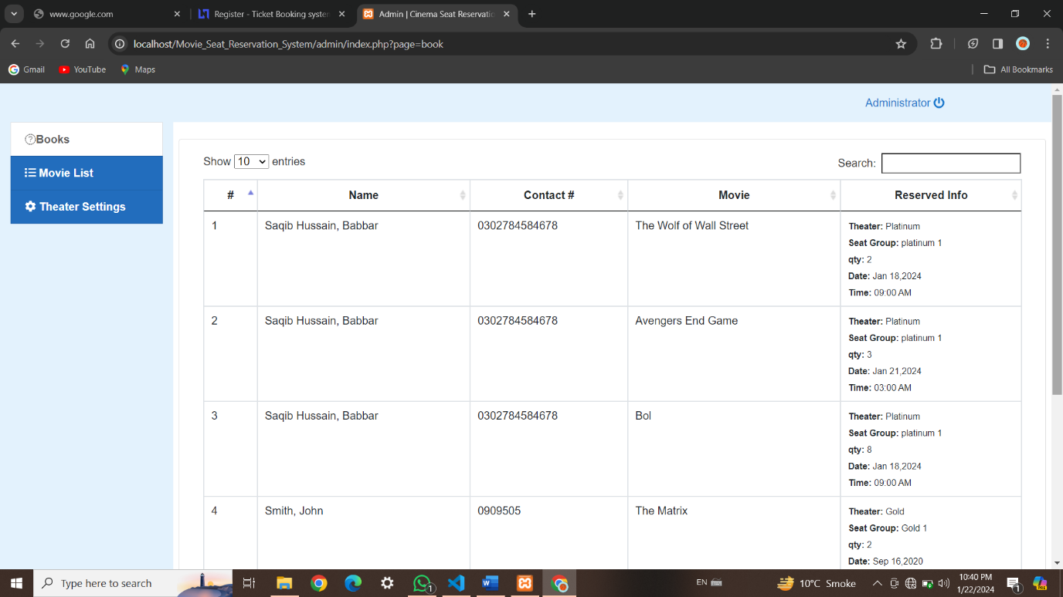

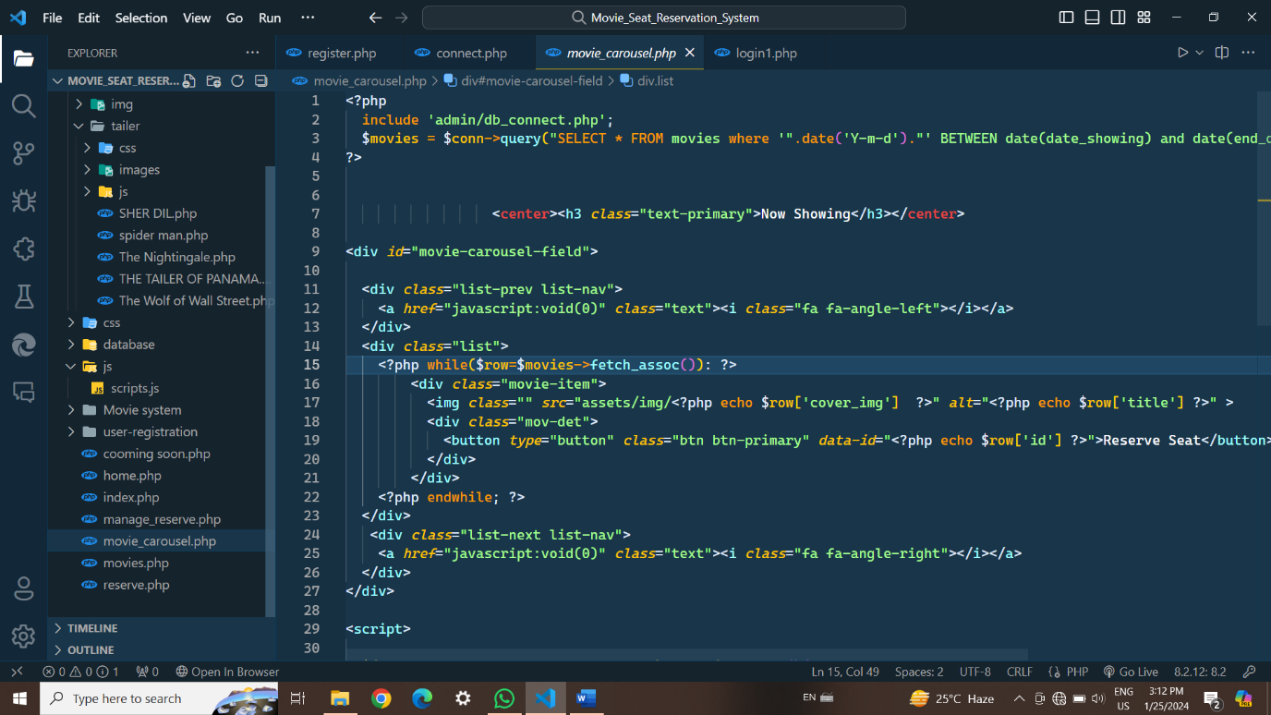

Theater settings:

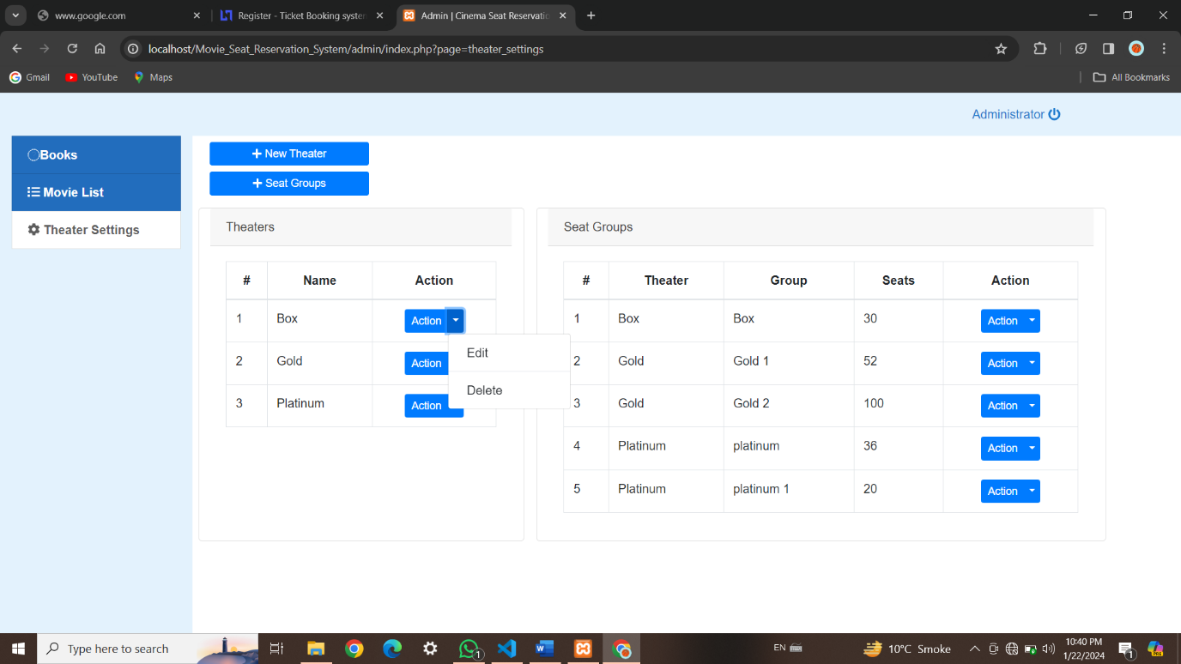

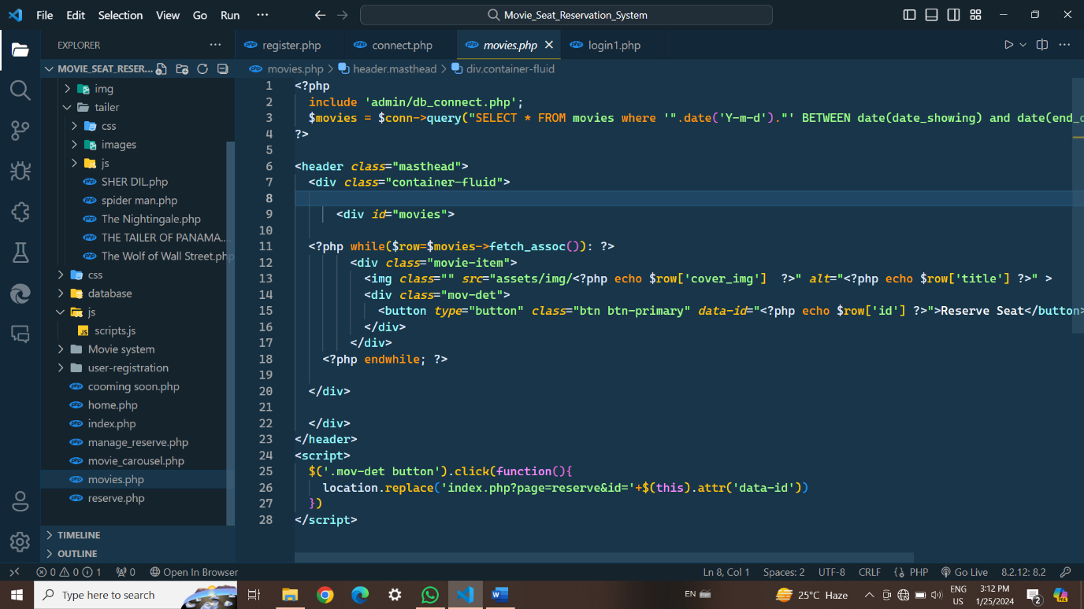

Movies lists:

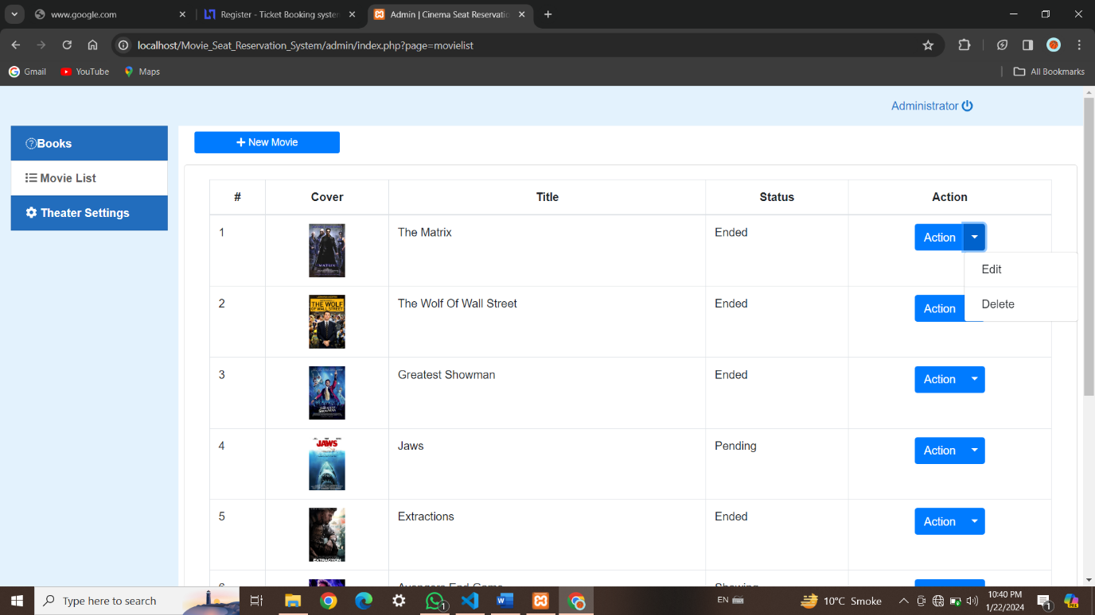

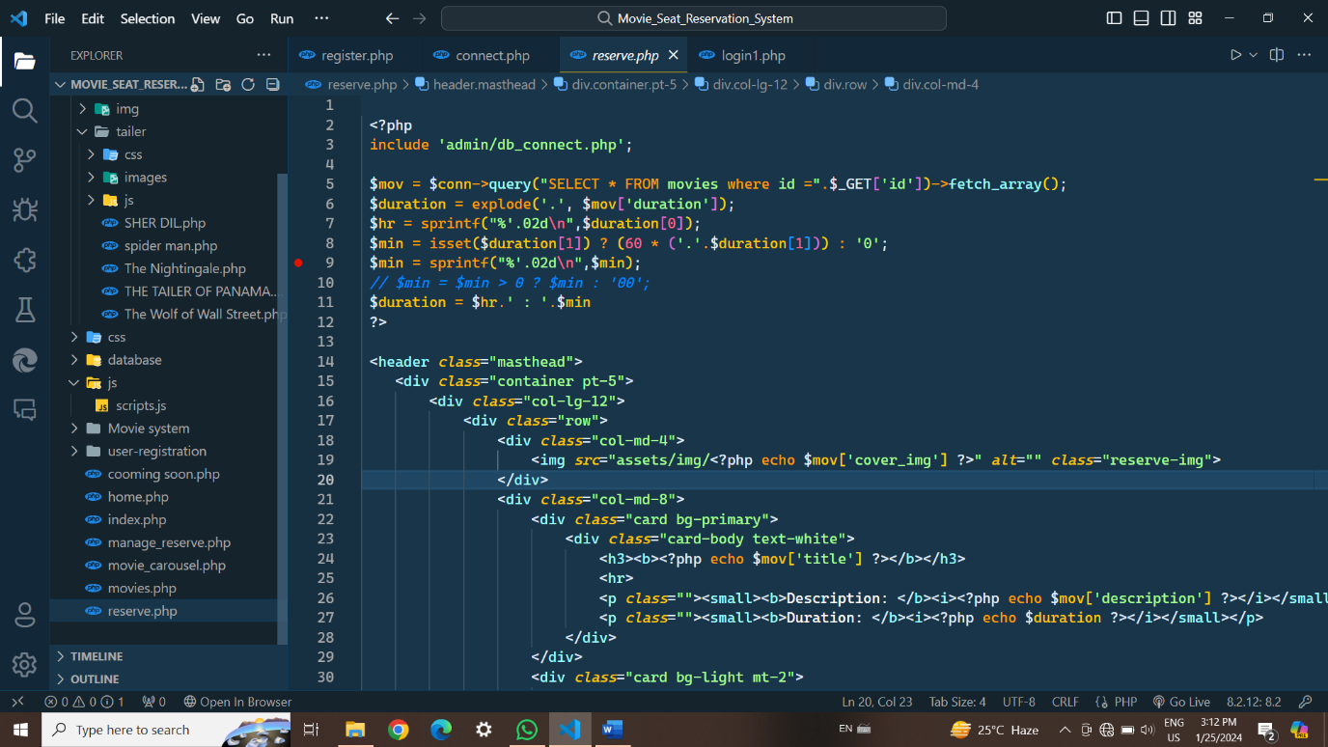

MEMEBERS OF THE PROJECT

1. SAQIB HUSSAIN
2. WASEEM
3. Ashad Arif